ROTU ARMY UMP: Official Portal

Ahmad Afiq Ahnaf Bin Harudin  
Faculty of Computing  
Universiti Malaysia Pahang,  
26600, Pekan, Pahang, Malaysia.  
Email: ahmadafiqahnaf@gmail.com

Dr. Salwana Mohamad @ Asmara

Faculty of Computing  
Universiti Malaysia Pahang,  
26600, Pekan, Pahang, Malaysia.  
Email: salwanamohamad@ump.edu.my

Abstract— ROTU ARMY UMP Portal is an official portal for ROTU ARMY UMP organization in University Malaysia Pahang. ROTU is stand for Pasukan Latihan Pegawai Simpanan which is a unit that train volunteer undergraduate students as volunteer reserve officers for Malaysian armed force in Malaysia. This project will share and display the important information and news about the ROTU ARMY UMP organization only. As problem statements, the student is having problem to find the information about the ROTU ARMY UMP. Also, the information about ROTU ARMY UMP in internet and UMP Portal is too concise. The student needs to attend at ROTU ARMY UMP kiosk during orientation event. This will consume much time and making it difficult for students to find out any information. The objective of the project is to design the database and the Graphical User Interface for ROTU ARMY UMP Portal. Also, this project will be focused to display and explaining the information about the ROTU ARMY UMP for the UMP students. This project will be developing to verify bugs of ROTU ARMY UMP Portal. The scope of the project is the portal only serves ROTU ARMY UMP information and news placed in University Malaysia Pahang. Also, the portal focuses on the UMP undergraduate students who having problem in finding information about the ROTU ARMY UMP only. The portal included the information and news of the ROTU ARMY UMP such as introduction, history, organization, profile, activities, gallery, alumni, and frequently asked questions. The portal also consists of administration section where the admin can update and editing the information and news of the portal. The expected result from this project is this portal will ease the information retrieval to the UMP students and give the administration to update and edit the information and news about the organization.

Keywords—ROTU ARMY, ROTU ARMY UMP, reserve officers

# Introduction

ROTU ARMY UMP Portal is an authority entrance for ROTU ARMY UMP association in University Malaysia Pahang. ROTU is represent Pasukan Latihan Pegawai Simpanan which is a unit that train volunteer college understudies as volunteer reserve officers for Malaysian equipped power in Malaysia. ROTU ARMY UMP Official Portal is a portal that shared all the information about the organization. There is existing portal which manage the ROTU ARMY organization from public universities such as UNIMAS, UM and UPM.

This portal consists of some pages such the Home, Login, Frequently Asked Question, Media Gallery, About Us, Organization Chart, Contact Us, Question Approval, Leave Apply, Leave Approval, and News Pages. With this project development, the efficiency in delivering the information will increase rapidly to the students especially. The information of ROTU ARMY UMP can be found in this portal without searching for any other portal, directly go to the ROTU ARMY UMP office or contact to the administration. This will consume time taken for the student to receive any information about it.

Additionally, this portal development will be focused to show and clarifying the data about the ROTU ARMY UMP for the UMP understudies. This task will be creating to confirm bugs of ROTU ARMY UMP Portal. The extent of the portal is the entryway just serves ROTU ARMY UMP data and news put in University Malaysia Pahang. Likewise, the project focuses on the UMP understudies who having issue in discovering data about the ROTU ARMY UMP as it were.

## Problem Statements

As the new intake students in UMP, the students have the opportunities in joining the ROTU ARMY UMP organization. **The main problem is they having issue in finding and get the information about the organization because they need to attend the ROTU ARMY UMP kiosk during the orientation event only.** Also, the information about the ROTU ARMY UMP in official UMP Portal or in internet is too concise.

## Objectives

There are three objectives in this project which are:

1. To design a ROTU ARMY UMP Portal system.
2. To develop a portal that display and explaining the information and news about the ROTU ARMY UMP for the UMP students.
3. To develop a portal that ease the student and staff to apply for training leave and approve it.
4. To verify bugs of the ROTU ARMY UMP Portal.

# Related works

## A. Existing Portal

ROTU UNIMAS portal is a system that serve the information of ROTU ARMY and Udara to the student and staff. This portal is used by student and staff from University Malaysia Sarawak. The public user also can visit this open portal. The average age that suitable to visit this portal range 18-year-old above especially for the first-year student. This portal is developed using bootstrap template from another bootstrap website. The user interface and functionality are developed by using HTML, JavaScript, and CSS programming languages. Also, the use of Google API in this portal can be seen in the sitemap. The data is stored in UNIMAS Datastore and MySQL for the database. The use of password-based authentication for login credentials. The server also is use from UNIMAS server to avoid anonymous or any ransomware attacking the portal. Also, the data and the portal can be controlled by the UNIMAS only. All the data will be store safely to secure the privacy. The portal is deployed in UNIMAS Official Portal, Google, Facebook, Twitter, YouTube, and Flickr. For any information or question can visit the official portal at http://www.ROTU.unimas.my/.

ROTU UPM portal is a framework that serve the data of ROTU ARMY just to the understudy and staff. This entrance is utilized by understudy and staff from University Putra Malaysia. The public client likewise can visit this open entrance. The normal age that reasonable to visit this entrance range 18-year-old above particularly for the main year understudy. This entrance is created utilizing own plan format. The UI and usefulness are created by utilizing HTML, JavaScript, and CSS programming dialects. Additionally, the utilization of Google API in this gateway can be found in the sitemap. The information is put away in UPM Datastore and Oracle for the data set. The administrator mindful in dealing with the data in the gateway. The worker likewise is use from UPM worker to keep away from unknown or any ransomware assaulting the entry. Likewise, the information and the entrance can be constrained by the UPM as it were. All the information will be store securely to get the protection. The entrance is sent in UPM Official Portal, Google, Facebook, Twitter, YouTube, and Instagram. For any data or question can visit the authority gateway at https://ROTU.upm.edu.my/.

ROTU UM portal is a system that serve the information of ROTU ARMY and Laut to the understudy and staff. This entrance is used by understudy and staff from University Malaya. The public user furthermore can visit this open passageway. The typical age that sensible to visit this section range 18-year-old above especially for the essential year understudy. This section is made using bootstrap format from Probootsrap. The UI and helpfulness are made by using HTML, JavaScript, and CSS programming lingos. Moreover, the use of Google API in this door can be found in the sitemap. The data is taken care of in UM Datastore and PostgreSQL for the informational collection. The admin fit in managing the information in the passageway. The laborer moreover is use from UM specialist to avoid obscure or any ransomware attacking the doorway. Moreover, the data and the passage can be compelled by the UM figuratively speaking. All the data will be store safely to get the security. The doorway is passed on in UM Official Portal, Google, Facebook, Twitter, YouTube, and Instagram. For any information or question can visit the position entrance at https://ROTU.um.edu.my/record. Table 2.1 shows the summary of the specification existing systems.

Table 2.1 – Specification of existing portal

|  |  |  |  |
| --- | --- | --- | --- |
| SPECIFICATION | ROTU UNIMAS | ROTU UPM | ROTU  UM |
| User | -Student and staff from University Malaysia Sarawak  -Average age 18 above | -Student and staff from University Putra Malaysia  -Average age 18 above | -Student and staff from University Malaya  -Average age 18 above |
| Interface | -Develop using bootstrap template from another bootstrap website  -Using HTML, JavaScript, and CSS programming languages  -Google API for sitemap | -Develop using own design template  -Using HTML5, JavaScript and CSS programming language  -Using Google API link for sitemap | -Develop using bootstrap template from Probootsrap  -Using HTML, JavaScript, and CSS programming language  -Using Google API for location |
| Database | -UNIMAS Datastore  -MySQL Database | -UPM Datastore  -Oracle Database | -UM Datastore  -PostgreSQL Database |
| Security | -Password based authentication for login  -UNIMAS server | -Information controlled by the admin only  -UPM server | -Information controlled by the admin only  -UM server |
| Deployment | -UNIMAS Official Portal  -Google  -Facebook  -Twitter  -YouTube  -Flickr | -UPM Official Portal  -Google  -Facebook  -Twitter  -YouTube  -Instagram | -UM Official Portal  -Google  -Facebook  -Twitter  -YouTube  -Instagram |
| Unit Involved | -ROTU ARMY  -ROTU Udara | -ROTU ARMY | -ROTU ARMY  -ROTU Laut |
| Website link | http://www.ROTU.unimas.my/ | https://ROTU.upm.edu.my/ | https://ROTU.um.edu.my/index |

## B. Advantage & Disadvantage of Existing Portal

At the previous section, the ROTU UNIMAS Portal is a system that serve the information of ROTU ARMY and Udara to the student and staff. The first advantage can be seen in this portal is the portal has a compatible and attractive Graphical User Interface. The arrangement of the information section and the related buttons section is neat and tidy which ease the user to read and find the information given. The Interface also look modern and elegant which follow the recent trend design. The second advantage of the portal is it has Question and Answer page. The user can view all the previous information that have been asked related to the ROTU UNIMAS. The user also can contact the admin by fill the contact form if having any question to ask to them. Apart from that, this portal also has several disadvantages. Firstly, the login page does not function and has error page. By clicking the login button, the system will display back the home page rather than proceed to the login form page. Secondly, the disadvantage of the portal is the Quick Links button also does not function. If the user clicking the button, it will proceed to the error page which show 404 error, page not found.

For the next portal, the ROTU UPM Portal which a framework that serve the data of ROTU ARMY just to the understudy and staff. This portal has come with some benefits which this portal has downloaded documents page. The user can download the documents because all the documents can be share publicly. Then, the portal has included the related link for other websites such as Tentera ARMY Malaysia Portal, UPM Official Portal and others. This links will ease the user to go and find the future jobs information which related to the army occupation. Besides that, the disadvantage for this portal the home interface is too crowded. The interface has less iconography which icon for the buttons is important to ease the user to memorize the icon function rather than texts. The second disadvantage is it has unremoved ADs. With this issue, the view in this portal will be distracted with unknown ads. If the user suddenly clicking the ads, it will open the unknown website which unsecure to the user devices. Also, having ads is not suitable for the formal portal.

Moreover, the ROTU UM Portal role as a system that serve the information of ROTU ARMY and Laut to the understudy and staff. This portal has some advantages which is the portal has News page about the activities related to the Unit. The admin will update the recent news that have been held by the ROTU UM. Then, the portal has full and concise information about their High Commandants. The information includes the rank, office contact number, office fax number, and email. Also, the portal has its disadvantages such as the Social Media buttons does not fully function. There only one social media button that function which is Facebook page button. If the user clicking the Facebook button, it will proceed to the Official ROTU UM Facebook page. The other social media button doe does not function such as Twitter, Instagram, and YouTube buttons. If the user clicks that button, it will constantly go to the previous page. Table 2.2 show the summary of the specification of the existing systems includes their advantages and the disadvantages.

Table 2.2 – Advantage & Disadvantage of existing portal

|  |  |  |
| --- | --- | --- |
| System | Advantage | Disadvantage |
| ROTU UNIMAS | - Graphical User Interface compatible and attractive | - Login page does not function and error |
| - Has Question and Answer page | - Quick Links button not function |
| ROTU UPM | - Has public share downloaded documents | - The home interface too crowded |
| - Include related link for other websites | - Has unremoved ADs |
| ROTU UM | - Has News page about activities related to the Unit | - Social Media button does not function |
| - Has full and concise information about their High Commandants | - Graphical User Interface too simple and less information provided |

# Proposed Design

## Flow chart

In this project, the flowchart will be designed to show the process of the ROTU ARMY UMP Portal occur. In APPENDIX A, the flowchart of the ROTU ARMY UMP Portal illustrated overall process of the portal.

Based on the APPENDIX A, the flowchart of the ROTU ARMY UMP is shown from Figure 7.1 until Figure 7.10. Generally, the flow begins with the Home Page. In Home Page, there are several subpages that the portal has includes the Login, Frequently Asked Question, Media Gallery, About Us, Organization Chart, Contact Us, Leave Apply, Leave Approval, Question Approval and News Pages.

## Context Diagram

In this project, the use of the Context Diagram is important to illustrate the simple flow between the system and the user. Refer in APPENDIX B, the Context Diagram of this system will be shown in Figure 7.11.

Based on the Context Diagram in APPENDIX B, the developer will develop the full complete ROTU ARMY UMP Portal and the portal will be test by the user. The portal will display and give the information related the organization. The user will view and get all the information from the portal. If the user has any question about the organization, the user can contact the admin by fill the contact form given in the portal as communication medium.

The student can apply the training leave by follow the guideline given in the page. The application will transfer to the staff page which need to be approved. The staff can view and response the student leave application by clicking the approved button.

## Use Case Diagram

Use Case Diagram is used in this project to give visual representation of potential interaction by the user between the portal. In APPENDIX C, there will show the Use Case Diagram of this project.

Based on the Use Case Diagram in APPENDIX C, the student, staff, or public user need to fill the contact form as shown in Figure 7.12. The details include the name, email, identities number (Matric ID, Staff ID, or MyKad Number), Contact Number, Title of the response, Type of User, and Comment. In type of user, the user needs to choose the relevant input such as citizen, student, or staff.

The contact form will be sent to the Question Approval page which monitor by the admin. The admin will receive all the information to be response it. Then, the admin will attach the question and answer at the FAQ page.

## Storyboard

The storyboard is including in this project to illustrate the storyline flow and the wireframe of the project. Refer in APPENDIX D, the storyboard of the ROTU ARMY UMP Portal will be explain through each screen include the screen title, layout, screen layout, and description.

Based on the storyboard in the APPENDIX D, the wireframe of each page has been attaching from Table 7.1 until 7.11. The storyboard will include some information about each page such as the Screen Title, Layout, Screen Layout, and Description.

## Hardware & Software Specification

In this proposed project, there is use of software and hardware requirements. Table 3.1 shows the list of the software tools that use in this project. Table 3.2 shows the list of the hardware tools that use to complete this project.

Table 3.1 – Software used for the project

|  |  |
| --- | --- |
| Software | Description |
| Visual Studio Code | To write the programming languages to design interface and develop the full project. |
| XAMPP | To integrate with the suitable server to load and test the project system. |
| Draw.io | To design the flowchart, storyboard, Use Case Diagram and Context Diagram of the project. |
| Microsoft PowerPoint | To create slide for the presentation of project |
| Microsoft Word | To write the project report |
| Google Chrome | To find the reference for the project |

Table 3.2 – Hardware used for the project

|  |  |  |
| --- | --- | --- |
| Hardware | Specification | Description |
| Personal Laptop | - Window 10 Pro  - Intel(R) Core (TM) i7-5500U CPU @ 2.40GHz 2.40 GHz Processor  - 4.00 GB RAM  - 64-Bit Operating System | To run the system and write the documentation and program languages. |
| Samsung External Hardisk (HDD) | - Samsung  - 1TB | To store data and back up it |
| iPhone 6 | - iOS 12.5  - 4.00 GB RAM  - 125 GB Storage | To record and edit the presentation video. |

## Hardware & Software Specification

In this proposed project, there is use of software and hardware requirements. Table 3.1 shows the list of the software tools that use in this project. Table 3.2 shows the list of the hardware tools that use to complete this project.

Table 3.1 – Software used for the project

|  |  |
| --- | --- |
| Software | Description |
| Visual Studio Code | To write the programming languages to design interface and develop the full project. |
| XAMPP | To integrate with the suitable server to load and test the project system. |
| Draw.io | To design the flowchart, storyboard, Use Case Diagram and Context Diagram of the project. |
| Microsoft PowerPoint | To create slide for the presentation of project |
| Microsoft Word | To write the project report |
| Google Chrome | To find the reference for the project |

Table 3.2 – Hardware used for the project

|  |  |  |
| --- | --- | --- |
| Hardware | Specification | Description |
| Personal Laptop | - Window 10 Pro  - Intel(R) Core (TM) i7-5500U CPU @ 2.40GHz 2.40 GHz Processor  - 4.00 GB RAM  - 64-Bit Operating System | To run the system and write the documentation and program languages. |
| Samsung External Hardisk (HDD) | - Samsung  - 1TB | To store data and back up it |
| iPhone 6 | - iOS 12.5  - 4.00 GB RAM  - 125 GB Storage | To record and edit the presentation video. |

# Expected outcome

For this section, the testing will be conducted to find the requirement from the user. The User Acceptance Test will be record as the user fill the feedback that will give to the student and the staff of the University Malaysia Pahang. Also, the feedback will be given to the public people. This test conducted to find the requirement that can be improve and add to the future improvise system. The use of the Malay language in this evaluation form is to ease the student and staff to understand properly the information given. Table 4.1 shows the Evaluation Form that use in this User Acceptance Test.

For the expected result from this test, the expectation that the project will satisfy the user and will ease the user to use the portal. Also, any problem that occurs and found from the test will be improvise as possible by the developer. The project can give many benefits to the user and the staff especially in ROTU ARMY UMP to manage their organization in this portal.

Table 4.1 – Evaluation Form for the project

|  |  |  |  |
| --- | --- | --- | --- |
| Bil. | Soalan | Ya | Tidak |
| 1. | Adakah anda berminat dengan system ini? |  |  |
| 2. | Adakah anda memahami segala informasi yang ada di dalam portal ini? |  |  |
| 3. | Adakah anda mempunyai sebarang kesukaran menggunakan portal ini? |  |  |
| 4. | Adakah maklumat yang diberikan dalam portal ini tidak terlalu ringkas? |  |  |
| 5. | Adakah portal ini boleh membantu anda dalam mencari segala maklumat yang berkaitan dengan ROTU ARMY UMP? |  |  |
| 6. | Adakah anda memahami cara penggunaan portal ini? |  |  |
| 7. | Adakah mudah untuk menggunakan portal ini? |  |  |
| 8. | Adakah portal ini boleh digunakan untuk masa hadapan? |  |  |
| 9. | Adakah ada penambah baikan untuk portal ini? |  |  |
| 10. | Adakah and berpuashati dengan portal ini? |  |  |

# Conclusions

In conclusion, ROTU ARMY UMP Portal is an authority entrance for ROTU ARMY UMP association in University Malaysia Pahang. ROTU is represent Pasukan Latihan Pegawai Simpanan which is a unit that train volunteer college understudies as volunteer reserve officers for Malaysian equipped power in Malaysia. ROTU ARMY UMP Official Portal is a portal that shared all the information about the organization. The main problem is they having issue in finding and get the information about the organization because they need to attend the ROTU ARMY UMP kiosk during the orientation event only. There is existing portal which manage the ROTU ARMY organization from public universities such as UNIMAS, UM and UPM that have solved the problem. The proposed solution to improve the management in ROTU ARMY Organization by developing the official website that will give information about the activities of the organization. The outcome for this project includes the development of the ROTU ARMY UMP Portal include the Home, Login, Frequently Asked Question, Media Gallery, About Us, Organization Chart, Contact Us, Question Approval, Leave Apply, Leave Approval and News Pages. The User Acceptance Test also conducted to observe the satisfy feedback from the user.

# References

Ahmad, A. (2021). Home. ROTU.unimas.my. Retrieved 8 June 2021, from http://www.ROTU.unimas.my/.

Contributors, W. (2021). Reserve Officer Training Unit - Wikipedia. En.wikipedia.org. Retrieved 8 June 2021, from https://en.wikipedia.org/wiki/Reserve_Officer_Training_Unit.

Muhammad, F. (2018). HOME | RESERVE OFFICER TRAINING UNIT (ROTU). ROTU.upm.edu.my. Retrieved 8 June 2021, from https://ROTU.upm.edu.my/.

Najmuddin, M. (2021). Rotu ARMY UMP. Rotu ARMY UMP. Retrieved 8 June 2021, from https://rotuARMYumpmy.blogspot.com/.

ROTU, U. (2021). Pusat Kokurikulum, Universiti Utara Malaysia - ROTU. Kokuum.uum.edu.my. Retrieved 8 June 2021, from [http://kokuum.uum.edu.my/unit/ROTU](http://kokuum.uum.edu.my/unit/palapes).

Rahimah, S. (2021). KOMPLEKS ROTU UNIVERSITI MALAYA. ROTU.um.edu.my. Retrieved 8 June 2021, from https://ROTU.um.edu.my/index.

# APPENDIX

In this section consist of the APPENDIX A until D. The Figures of the Flowchart, Context Diagram, Use Case Diagram, and the Storyboard of the ROTU ARMY UMP Portal as shown below.

APPENDIX A – Flowchart of ROTU ARMY UMP Portal

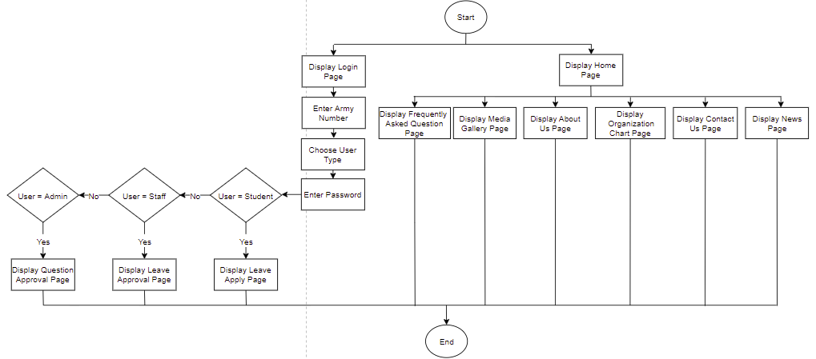

Figure 7.1 – Flowchart of the Home include Login Page

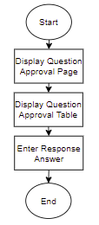

Figure 7.2 – Flowchart of the Question Approval Page

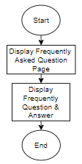

Figure 7.3 – Flowchart of the Frequently Asked Question Page

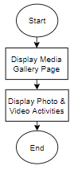

Figure 7.4 – Flowchart of the Media Gallery Page

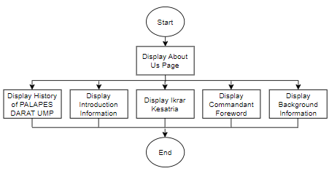

Figure 7.5 – Flowchart of the About Us Page

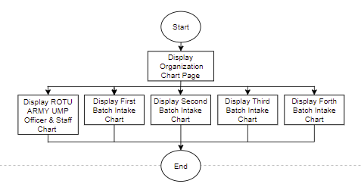

Figure 7.6 – Flowchart of the Organization Chart Page

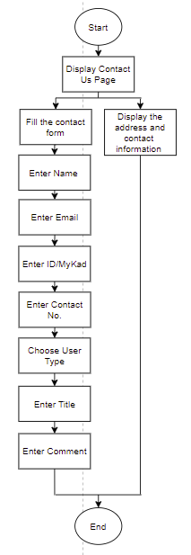

Figure 7.7 – Flowchart of the Contact Us Page

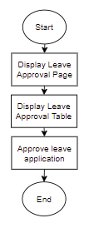

Figure 7.8 – Flowchart of the Leave Approval Page

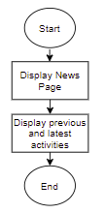

Figure 7.9 – Flowchart of the News Page

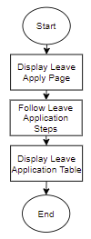

Figure 7.10 – Flowchart of the Leave Apply Page

APPENDIX B – Context Diagram of ROTU ARMY UMP Portal

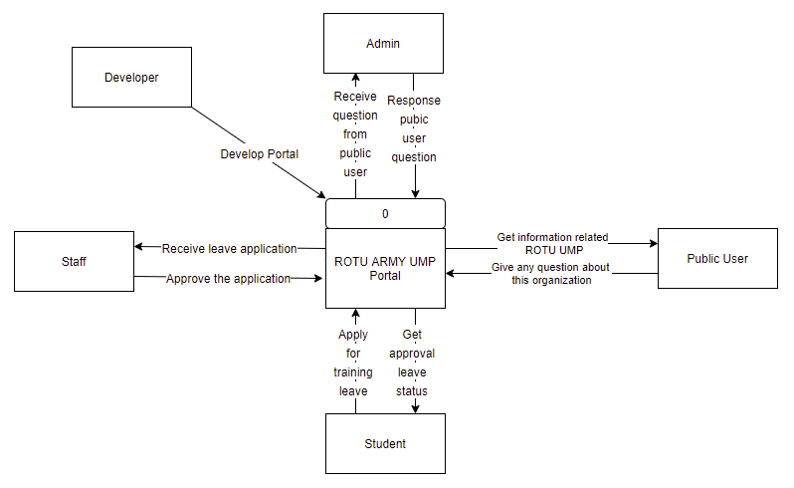

Figure 7.11 – Context Diagram of ROTU ARMY UMP Portal

APPENDIX C – Use Case Diagram of ROTU ARMY UMP Portal

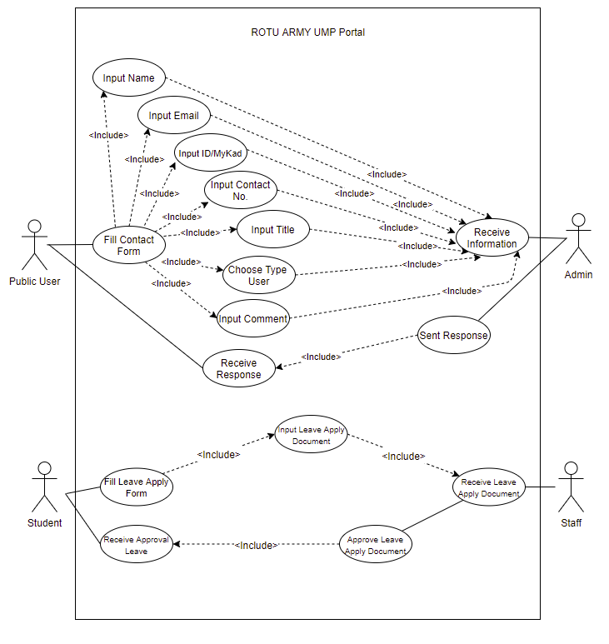

Figure 7.12 – Use Case Diagram of ROTU ARMY UMP Portal

APPENDIX D – Storyboard of ROTU ARMY UMP Portal

Table 7.1 – Home Page of ROTU ARMY UMP Portal

|  |  |
| --- | --- |
| Screen Title | Home Page |
| Layout | 01 |
| Screen Layout |  |
| Description | At the top of the page, there has some menu button such as Home, About Us, Chart Organization, Media Gallery, Contact Us, News and FAQ. The user can search any keyword and content that include in this portal by clicking the search box and type the keywords. At the left side page, there has a button which is Login button that will proceed to login subpage. The user can click each button to proceed the different page with different content. The user can slide the images by clicking the left or right button to go to next images. The image of the activities or events will be shown in the image slides. Also, this page includes some preview images of any activities involved and the sitemap of base office at the bottom page. |

Table 7.2 – Login Page of ROTU ARMY UMP Portal

|  |  |
| --- | --- |
| Screen Title | Login Page |
| Layout | 02 |
| Screen Layout |  |
| Description | In this page, the user can login the internal page by clicking the left side login button. Login page will pop up and the user can fill all the information required. The information includes the army number, user type and the password. The user type consists with student, staff and admin. The army number and password are fixed in the datastore which will be given to the internal user only. |

Table 7.3 – Frequently Asked Question Page of ROTU ARMY UMP Portal

|  |  |
| --- | --- |
| Screen Title | Frequently Asked Question Page |
| Layout | 03 |
| Screen Layout |  |
| Description | In the FAQ page, the user can view the question and the answer related with the organization. The question may vary which has been ask from the student, staff, or public citizen. The personal information of the user does not show as to protect the privacy of the user. The admin of the portal will answer the question as soon as possible. |

Table 7.4 – Media Gallery Page of ROTU ARMY UMP Portal

|  |  |
| --- | --- |
| Screen Title | Media Gallery Page |
| Layout | 04 |
| Screen Layout |  |
| Description | In this page, the user can view the photo and the video collection. The user can play the video and photo can be slides. All the image is related with the activities and event that has been conduct previously. |

Table 7.5 About Us Page of ROTU ARMY UMP Portal

|  |  |
| --- | --- |
| Screen Title | About Us Page |
| Layout | 05 |
| Screen Layout |  |
| Description | In this page, the user can view and read the information that related to this organization. The information includes the Introduction Information, History ROTU ARMY UMP, Ikrar Kesatria, Commandant Foreword and Background Information. Also, there have the image that role as the attractiveness for the page. |

Table 7.6 Organization Chart Page of ROTU ARMY UMP Portal

|  |  |
| --- | --- |
| Screen Title | Organization Chart Page |
| Layout | 06 |
| Screen Layout |  |
| Description | In this page, the user can view the information of the ROTU ARMY UMP organization chart. There are five organization charts in this page. The organization charts include all ROTU ARMY UMP Officer & Staff Chart, First Intake Batch Chart, Second Intake Batch Chart, Third Intake Batch Chart, and Forth Intake Batch Chart. The information each organization chart includes the Image, ID Rank, and Name. |

Table 7.7 Contact Us Page of ROTU ARMY UMP Portal

|  |  |
| --- | --- |
| Screen Title | Contact Us Page |
| Layout | 07 |
| Screen Layout |  |
| Description | In this page, the user can view the contact detail of the organization. The details include the address, contact number, email, and fax number. The user also can fill the contact form if have any question relate the organization. The information consists with the name, email, ID or MyKad, contact number, title, response category, user type, comment, and attachment. Then, the user needs to click the submit button to send the contact form to the admin. Also, the user can view the sitemap of the office location of the organization. |

Table 7.8 Question Approval Page of ROTU ARMY UMP Portal

|  |  |
| --- | --- |
| Screen Title | Question Approval Page |
| Layout | 08 |
| Screen Layout |  |
| Description | In this page, only admin can enter this page. The admin can view the feedback from the user in the list table above. The admin also can search any data information by clicking and enter the keyword in the searching box. The feedback information includes the username, email, ID/MyKad, contact number, user type, title and the comment of the feedback. The admin can reply to the response by enter the content at the response box. Then, by clicking the submit button, the response will proceed and display in the FAQ page. |

Table 7.9 News Page of ROTU ARMY UMP Portal

|  |  |
| --- | --- |
| Screen Title | News Page |
| Layout | 09 |
| Screen Layout |  |
| Description | In this page, the user can view news of the ROTU ARMY UMP. The user can read the previous and latest news that have been or will be conduct by the organization. User also can search any news by clicking the search box and enter the keyword. |

Table 7.10 Leave Apply Page of ROTU ARMY UMP Portal

|  |  |
| --- | --- |
| Screen Title | Leave Apply Page |
| Layout | 10 |
| Screen Layout |  |
| Description | In this page, only the student can enter this page. The student can apply the leave by follow the simple steps given. The student needs to download the document given. Then, follow the instruction and edit the red bold information only. The student needs to save and rename as shown above and upload the document again. Then, the student needs to click the Submit button and the submitted document will appear in the table. Thus, the student needs to wait until the submission document approved by the staff. If in waiting mode, the status shows as PENDING while in completed status, the status change to COMPLETED. |

Table 7.11 Leave Approval Page of ROTU ARMY UMP Portal

|  |  |
| --- | --- |
| Screen Title | Leave Approval Page |
| Layout | 11 |
| Screen Layout |  |
| Description | In this page, only the staff can login in this page. The staff can view the details of the students who apply for training leave. The staff can view the queue number, title, date, and status. The staff can download the document by clicking the download button. It will download the document to the devices. The staff can approve the student application by clicking the approve button. It will generate the status to the completed at the status column and will change at the student status column too. |